

IMAGE CONSENT OPTIONS

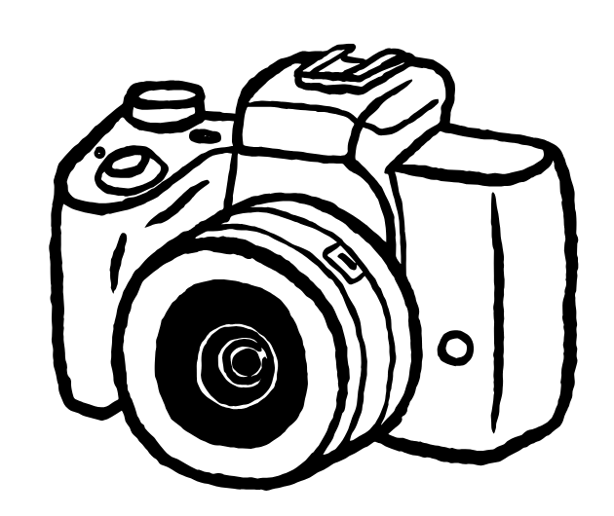

If you are comfortable appearing in photos/videos taken at this event, you don’t need to do anything.

If you do not wish to appear in photos or videos taken at this event*, please put a label with a red sticker on your shirt in a visible position. This is to indicate to the photographer not to include you in their photos/videos.

*Please note: This applies to close-up photos or videos where you are the main focus only. General group shots or wide-angle images where you are not clearly identifiable may still be taken and published online.

Thank you for helping us keep this event a safe and inclusive space for all.

